Exercise Solution

Task 1: Basic Unconditional Jump
Write a program that:
Initializes AX to 10.
Uses an unconditional jump to skip over the code that would assign 5 to BX.
After the jump, store the value of AX in CX.

INPUT:
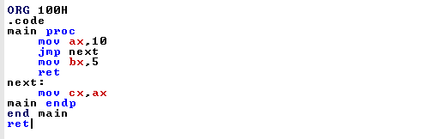
OUTPUT:
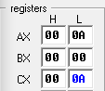

Task 2: Compare and Jump if Greater
Write a program that:
Sets AX to 4 and BX to 2.
Compares AX and BX.
If AX is greater than BX, jump to a label greater where CX is set to 1.
If AX is not greater than BX, set CX to 0.

INPUT:
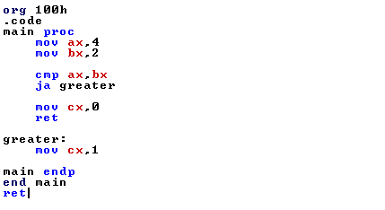
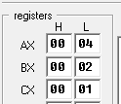
OUTPUT:

Task 3: Using a Loop with Unconditional and Conditional Jumps
Write a program that:
Initializes CX to 3.
Creates a loop where CX is decremented in each iteration.
Uses an unconditional jump to repeat the loop until CX becomes 0.
Stop the loop when CX is 0.

INPUT:
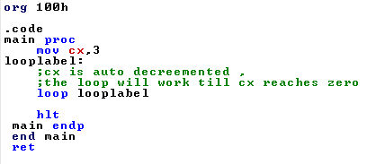
OUTPUT:
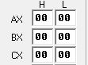

Task 4: Check for Even or Odd
Write a program that:
Loads a value of 5 into AX.
Checks if AX is even or odd using a conditional jump.
If AX is even, jump to a label even and set BX to 1.
If AX is odd, set BX to 0.

INPUT:
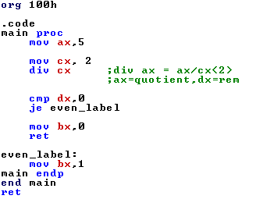
OUTPUT:
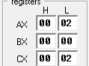

Task 5: Counting Up to a Limit
Write a program that:
Initializes AX to 0 and BX to 5.
Creates a loop that increments AX by 1 on each iteration.
Continues the loop until AX reaches the value in BX using a conditional jump to
exit the loop.

INPUT:

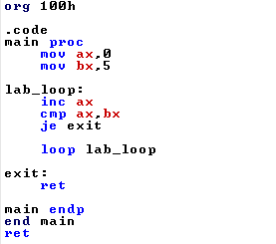

OUTPUT:
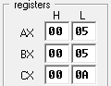

Task 6: Multiplication Table with Loop
Write a program that:
Sets AX to 2.
Uses a loop to calculate the first five multiples of AX (e.g., 2, 4, 6, 8, 10).
In each loop iteration, multiply AX by the loop counter and store the result in BX.
Stop after five iterations.
INPUT:
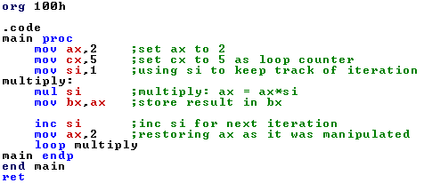
OUTPUT:
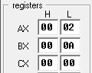

Task 7: Conditional Jump Based on Comparison
Write a program that:
Loads 10 into AX and 8 into BX.
Compares AX and BX.
Jumps to different labels based on whether AX is greater than, less than, or equal
to BX, and set CX to 1, 2, or 3 accordingly.

INPUT:
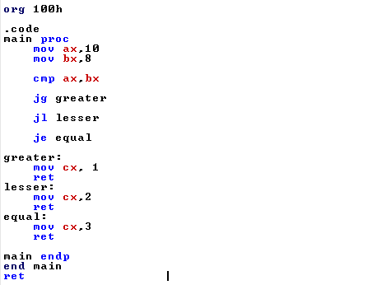
OUTPUT:
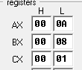

Task 8: Countdown Loop Using Jumps
Write a program that:
Initializes AX to 10.
Uses a loop to decrement AX by 1 on each iteration.
Exits the loop when AX reaches 0, using a conditional jump.

INPUT:
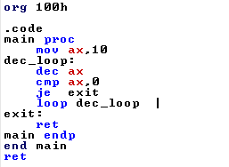

OUTPUT:




